**Design and Simulation of Solar Powered BLDC Motor**

**R. V. Borkar[1], Krushna Padile2, Ramakrishna Kadam3, Abhishek Patil4**

Assistant Professor, P.E.S’s. Modern College of Engineering, Pune, India1

BE, Electrical, P.E.S’s. Modern College of Engineering, Pune, India*2*

BE, Electrical, P.E.S’s. Modern College of Engineering, Pune, India 3

BE, Electrical, P.E.S’s. Modern College of Engineering, Pune, India 4

ABSTRACT:

Development of renewable energy sources is accelerating due to soaring oil prices and the depletion of fossil fuels, Water supplies such as wells and dugouts can often be developed on the open range. However, the availability of power supplies on the open range is often limited, so some alternate form of energy is required to convey water from the source to a point of consumption. Solar energy is an abundant source of renewable energy that can be exploited for pumping water in remote locations.

The agriculture sector in our country is highly dependent on rainfall. The system is fully based on renewable energy which is always available without any limitations. Technological improvement in electricity generation by solar system makes the system more efficient. So this scheme can be implemented for irrigation purpose to solve the problem of load shedding. In this way solar power helps to farmer to reduce cost of electricity and have good advantage if additional power supplied to utility grid.

This is a simple, cost effective and efficient brushless DC (BLDC) motor drive for solar photovoltaic (SPV) array fed water pumping system. A zeta converter is utilized in order to extract the maximum available power from the SPV array.

The proposed control algorithm eliminates phase current sensors and adapts a fundamental frequency switching of the voltage source inverter (VSI), thus avoiding the power losses due to high frequency switching. No additional control or circuitry is used for speed control of the BLDC motor. The speed is controlled through a variable DC link voltage of VSI. An appropriate control of zeta converter through the incremental conductance maximum power point tracking (INC-MPPT) algorithm offers soft starting of the BLDC motor.

The proposed water pumping system is designed and modelled such that the performance is not affected under dynamic conditions. The suitability of proposed system at practical operating conditions is demonstrated through simulation results using MATLAB/ Simulink.

KEYWORDS: Solar PV array, Zeta Converter, INC MPPT, VSI, BLDC Motor.

**1. INTRODUCTION**

The most crucial energy asset and also essential supportable asset is the solar energy because the vast amount of solar energy is effortlessly accessible for energy generation. Since it is spotless, contamination free and unlimited, the PV systems have been utilized for a long time. The quantity of electric power yield by PV system relies on the climate conditions. Since solar cell VI characteristic is nonlinear, it is imperative to utilize a MPPT system for extracting maximal energy from the solar panel.

Electric machines are a method for changing over energy. Motors are utilized to change over mechanical energy from electrical energy. In regular daily existence, electrical motors are generally used to power a large number of systems but a developing consideration towards BLDC drive has been examined in this proposed project. Brushless DC (BLDC) motor is a perfect drive for low and medium power applications as a result of its high effectiveness, high torque/inertia ratio, high volume of energy, low maintenance requirement and an extensive variety of speed control. It is otherwise called electronically commutated motor as there are no mechanical brushes and commutator. An electronic commutation with the help of rotor position detected by Hall-Effect position sensor is utilized. Consistently, the dc-dc converters are necessary to have stable output voltage regardless of changes under a variety of conditions. In addition, the closed loop controlled dc-dc converters possess over-current and over-voltage protection when they are regulated through current and voltage mode. The closed loop systems are more delicate to ecological condition than the open-loop system. In this way, it is basic to have a controller with low affectability to climate and natural conditions. The structural configuration of solar PV array fed BLDC motor having a wide consideration of working agreeably under different environmental conditions.

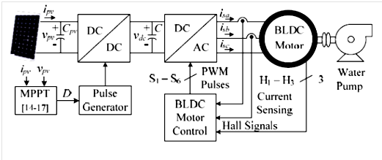

**Fig. 1 Conventional SPV fed BLDC motor driven water pumping system.**

The dc-dc converters are predominantly controlled in Voltage Mode Control (VMC) and Current Mode Control (CMC). The VMC has one closed loop where the yield voltage is determined and calibrated with the reference voltage. The Current control mode consists of dual closed loop where the external loop utilizes the yield voltage as feedback signal. The internal closed loop provides feedback signal only by utilizing the inductor current. Additionally current control modes have innate over-current protection and higher transmission than the voltage control mode. The main feature of CMC is the most excellent mode of control for dc-dc converters. In any case, the additional current identifying block, which incorporates the current sensor, the voltage level shifting circuit and the analog to digital converter (ADC) brings lack of quality and additional cost. For these, the sensor less current controlled dc–dc converter/ advanced current control technique, which operates in current control mode with all the previously mentioned points of interest and incredible possibilities however without requiring a current recognizing module. For the PCC, a calculation was explored in to take out the inductor current trouble in current control modes. In any case, all together to keep up the current control loop stability, the particular system of current control mode with pulse width adjustment ought to be done, and it limits the adaptability of framework outline. The viability to take out the unsettling influence in cycle by PCC with leading edge PWM modulation system was checked by hypothetical Derivation.

With the foretasted look into examination, to acknowledge current observer with sensor less current control, an exact framework modeling was executed. But, it is excessively intricate. Subsequently to make the framework straightforward, an input voltage feed forward current observer in terms of computational intricacy was built up. Here, it viably taking out the effect of input voltage fluctuations however current estimation error is generally vast because of overlook of the parasitic parameters. A broadened Kalman filter based current observer was assembled to upgrade the current estimation precision. An overwhelming model to enhance the current control execution was explored. The current estimation blunder happens because of the impact of parasitic parameters. In the previously mentioned research achievements, parameter variation issues and voltage loop steady-state errors are not discussed. To decide parasitic parameters, an extra signal testing module is required, which improves the current estimation all the more precisely. The end goal to get a more exact current estimation error, the grouping of PI controller is presented from the PCC controller. The mix impact of voltage loop PI controller is nullified by zero at origin, to diminishing the output voltage steady state error. The issue is that the impact of parasitic parameters can bring about the framework shaky. This issue can be tackled by online parameter estimation. In segment III.D PCC, is intended to self-correcting the output voltage steady state error can take out the zero at the starting point created by PCC controller to accomplish no output voltage steady state error without considering any parasitic parameters.

Already buck, boost and buck-boost converters have been utilized to improve PV system efficiency by transferring the generated output power from PV array to load. Zeta Converter with the presence of output inductor provides the constant current with ripple free. Even though combination of similar type of components as a Cuk converter, the zeta converter functioning as non-inverting buck-boost converter. This main feature prevent occurrence of additional circuits for negative voltage sensing henceforth minimizing intricacy and restrain the system response. A zeta converter which conveys directed yield voltage with power quality and to enhance proficiency. The advanced framework is controlled in two phases, viz. INC-MPPT and PCC technique.

Different MPPT techniques have been considered in PV power applications. The previous perturb and observe (P&O) and hill climbing strategies, tracks the maximum power point (MPP) by more than once incrementing or decrementing the yield voltage at the MPP of the PV module. The execution of the strategy is generally basic, yet it can't track the MPP when the irradiance differs rapidly with time.

Likewise, it might bring about framework climate over the extreme power points because of impact of estimation commotion. The incremental conductance strategy is too frequently utilized as a part of PV frameworks. This strategy tracks the MPP by looking at the incremental and prompt conductance of the PV array. It requires less conversion time, and the direct control of duty cycle is accommodated with this work.

1. **2.OPERATION OF PROPOSED SYSTEM**
2. The SPV array generates the electrical power demanded by the motor-pump. This electrical power is fed to the motor-pump via a zeta converter and a VSI. The SPV array appears as a power source for the zeta converter as shown in Fig.1. Ideally, the same amount of power is transferred at the output of zeta converter which appears as an input source for the VSI. In practice, due to the various losses associated with a DC-DC converter, slightly less amount of power is transferred to feed the VSI. The pulse generator generates, through INC-MPPT algorithm, switching pulses for IGBT (Insulated Gate Bipolar Transistor) switch of the zeta converter. The INC-MPPT algorithm uses voltage and current as feedback from SPV array and generates an optimum value of duty cycle. Further, it generates actual switching pulse by comparing the duty cycle with a high frequency carrier wave. In this way, the maximum power extraction and hence the efficiency optimization of the SPV array is accomplished.

**3. DESIGN OF PROPOSED SYSTEM**

A. Solar PV Array

Solar PV Array acts as an Input DC Voltage source. It converts DC Voltage source to AC Voltage source Using VSI. In addition, the performance of the BLDC motor-pump is influenced by the mechanical and electrical losses associated with them. To compensate these losses, the size of SPV array is selected with slightly more maximum power capacity to ensure the satisfactory operation regardless of the power losses. Therefore the SPV array of maximum power capacity of Pmpp= 3.4 kW under STC (STC: 1000W/m², 25°C, AM 1.5), slightly more than demanded by the motor-pump is selected and its parameters are designed accordingly.

Current of SPV array, No of modules in series:

No of modules in Parallel

B. Zeta Converter

It’s a DC-DC Convertor, Made up of 2 capacitors & 2 Inductors; Capable of operating in either Step-up or Step-down Mode. Used to draw maximum power from the Solar PV array with minimum power losses. Pulse Generator is used to operate Zeta convertor. Works on the principle of Incremental conductance-Maximum power point tracking Algorithm. (INC-MPPT), due to this soft starting of BLDC Motor is possible. Output current is continuous & ripple free, Output efficiency is high & Economical. The zeta converter is the next stage to the SPV array. Its design consists of the estimation of the various components such as input inductor, L1, output inductor, L2and intermediate capacitor, C1. These components are so designed that the zeta converter always operated in continuous conduction mode resulting in the reduced stress on them.

Duty Cycle:

Average Current Flowing thorough the dc link:

--------------------------------------------------------- (2)

C. INC MPPT ALGORITHM

An efficient and commonly used INC-MT technique in various SPV array based applications is utilized in order to optimize the power available from SPV array and to facilitate a soft starting of BLDC motor. This technique allows perturbation in either the SPV array voltage or the duty cycle. The former calls for a PI (Proportional-Integral) controller to generate a duty cycle [8] for the zeta converter, which increases the complexity. Hence, the direct duty cycle control is adapted in this work. The INC-MPPT algorithm determines the direction of perturbation based on the slope of *Ppv*-*vpv* curve, shown in Fig. 2. As shown in Fig.2, the slope is zero at MPP, positive on the left and negative on the right of MPP, i.e.

at MPP

Left of MPP

Right of MPP

Since,



Fig.2 Illustration of INC-MPPT with Solar P-V Characteristics

Therefore,

= at MPP

> at left of MPP

< at right of MPP

Thus, based on the relation between incremental conductance and instantaneous conductance, the controller decides the direction of perturbation as shown in fig. and increases/decreases the duty cycle accordingly. For instance, on the right of MPP, the duty cycle is increased with a fixed perturbation stops once the operating point reaches the MPP. However, in practice, operating point oscillates around the MPP.

As the perturbation size reduces, the controller takes more time to track the MPP of SPV array. An intellectual agreement between the tracking time and the perturbation size is held to fulfill the objectives of MPPT and soft starting of BLDC motor. In order to achieve soft starting, the initial value of duty cycle is set as zero. In addition, an optimum value of perturbation size (ΔD= 0.001) is selected, which contributes to soft starting and also minimizes oscillations around the MPP.

D. Voltage Source Inverter

Used to transfer real power from a DC Power source to AC Load (Motor acts as AC Load). Avoids power losses due to higher switching frequency. VSI is operated in Fundamental Frequency Switching through an Electronic Commutation of BLDC Motors, which eliminated power losses and improves Efficiency. A new design approach for the estimation of DC link capacitor of the VSI is presented in this sub-section. This approach is based on a fact that 6th harmonic component of the supply (AC) voltage is reflected on the DC side as a dominant harmonic in the three phase supply system. Here, the fundamental frequencies of the output voltage of the VSI are estimated corresponding to the rated speed and the minimum speed of the BLDC motor essentially required to pump the water. These two frequencies are further used to estimate the values of their corresponding capacitors. Out of the two estimated capacitors, larger one is selected to assure the satisfactory operation of the proposed system even under the duration of minimum solar irradiance level.

E. BLDC Motor

BLDC Motor connected with Water pump .Speed can be controlled through Variable DC link voltage of VSI No external circuit or control is required for speed control of BLDC Motors. Advantages - High Efficiency, High reliability, High Torque/Inertia ratio, improved cooling, No Maintenance required, Low radio frequency Interference. Specification: 1 Kw, 48 V, 3000rpm.

**4. PERFORMANCE OF PROPOSED SYSTEM**

The tracking time is intentionally increased at the starting by adapting a low value of perturbation size (Δ*D* = 0.001) in order to achieve the soft starting of BLDC motor. The low value of Δ*D* causes the reduced rate of rise of DC link voltage of VSI resulting in a smooth and soft starting of the motor. However, a negligible tracking time is required under the dynamic variation in irradiance level as shown in Fig. 3.

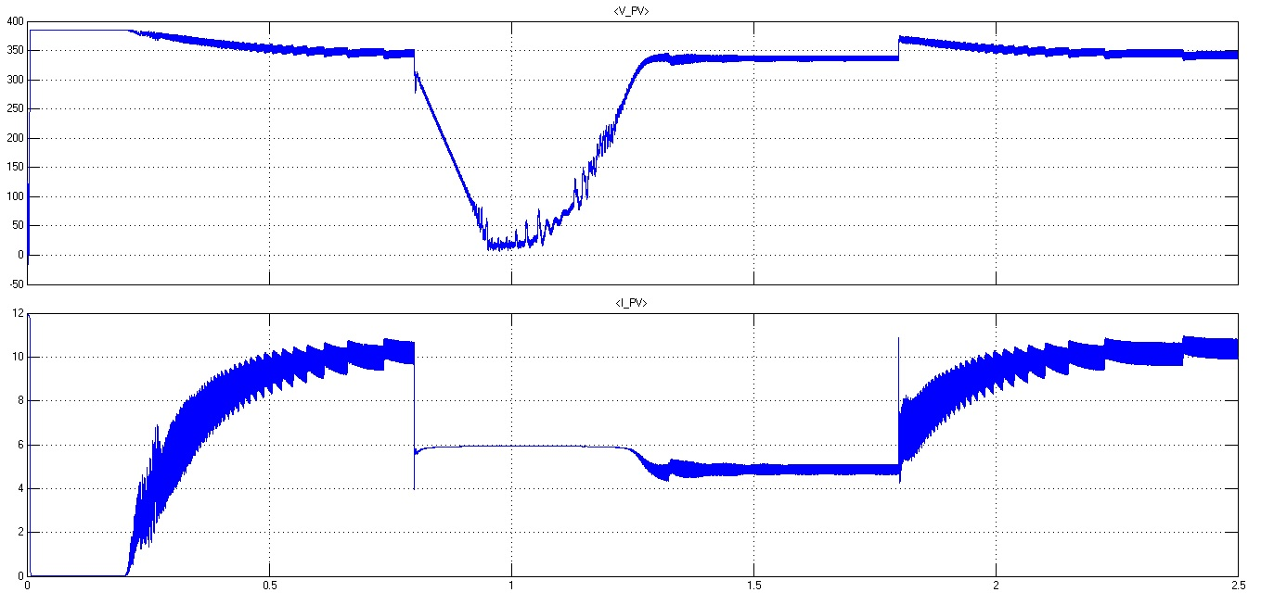

Fig.3 Output of Solar PV Array Vpv & Ipv

The operation of converter in this mode reduces the stress on power devices and component. These converter indices follow the variation in the weather condition and vary in proportion to the solar irradiance level, such as *iL1*, *vc1*, *iL2* and *vdc* shown in Fig. 4.

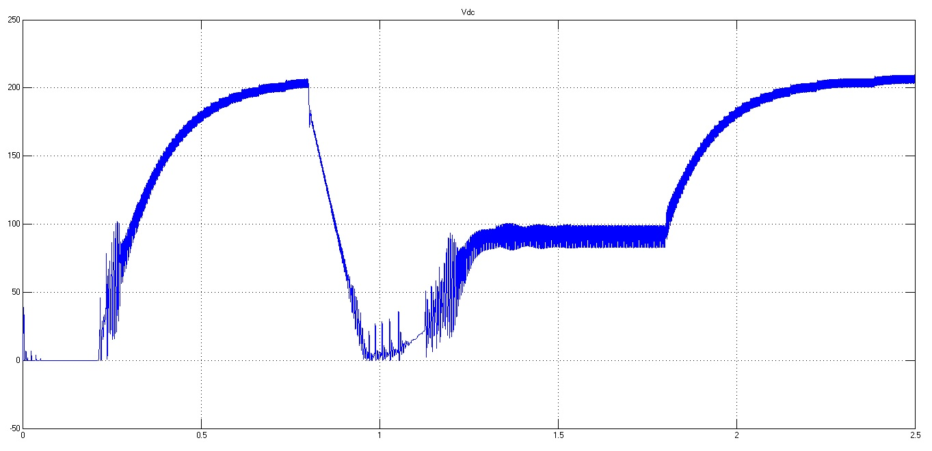

Fig.4 Zeta Converter Output Vdc

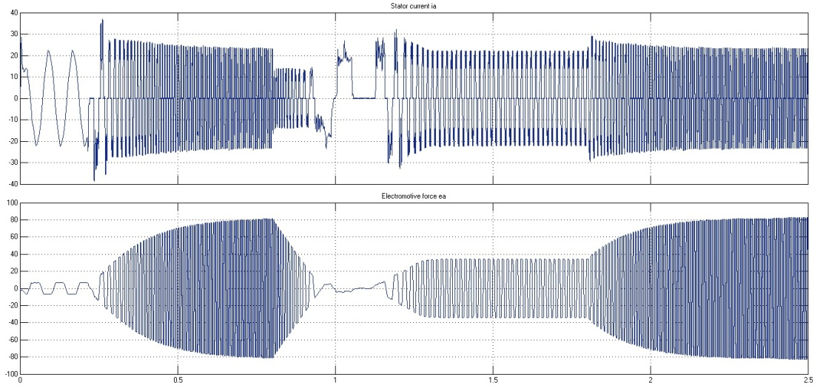

Fig.5 Stator Current and Electromagnetic Force

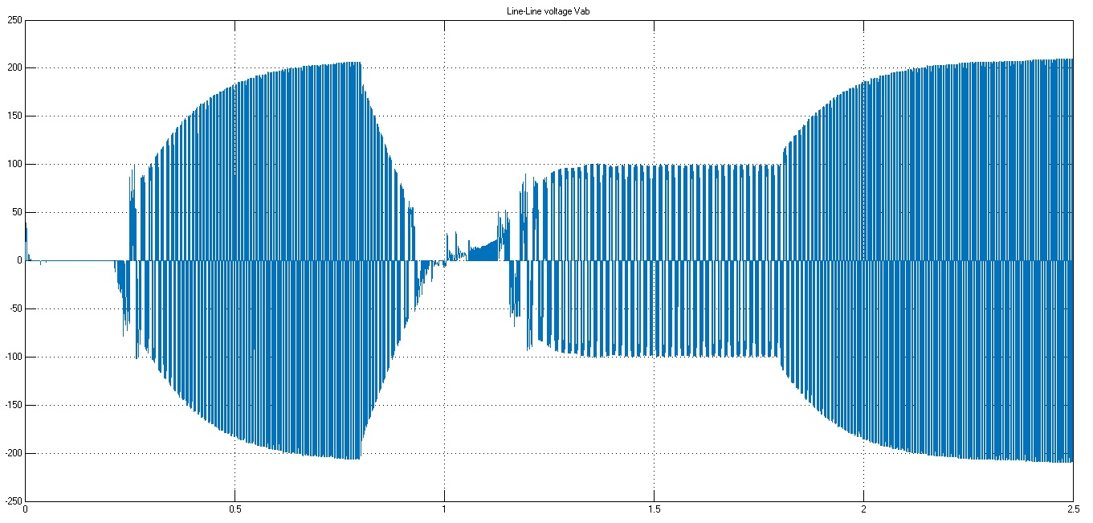

Fig.6 Voltage Source Inverter Output

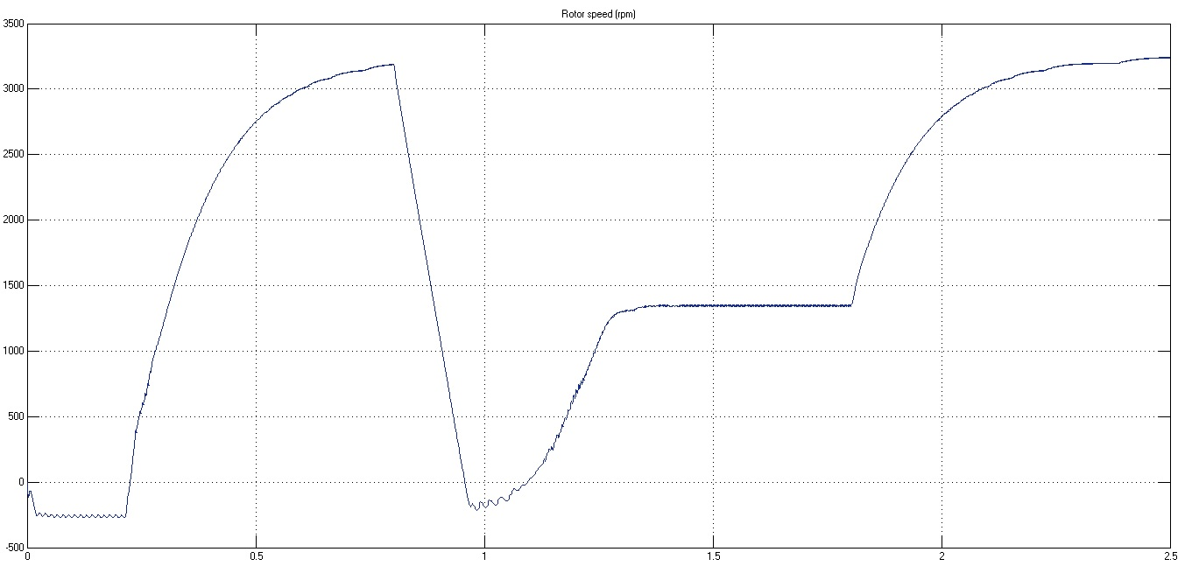

Fig.7 Rotor speed

The starting and steady state behaviors of the BLDC motor-pump at 1000 W/m2 is shown in Fig. 4(c). All the motor indices such as the back EMF, *ea*, the stator current, *isa*, the speed, *N*, the electro-magnetic torque developed, *Te* and the load torque, *TL* reach their corresponding rated values under steady state condition. The soft starting along with the stable operation of motor–pump is observed and hence the successful operation of proposed system is verified. However, a small pulsation in *Te* results in due to the electronic commutation of the BLDC motor. As the solar irradiance level alters, all the BLDC motor – pump indices vary in proportion to the solar irradiance level as shown in Fig. 5, 6, 7.

**5. Conclusion**

The proposed system has been designed and modelled appropriately to accomplish the desired objectives and validated to examine various performances. The performance evaluation has justified the combination of zeta converter and BLDC motor for SPV array based water pumping. The system under study has shown various desired functions such as MPP extraction of the SPV array, soft starting of BLDC motor, fundamental frequency switching of VSI resulting in a reduced switching losses, speed control of BLDC motor without any additional control and an elimination of phase current and DC link voltage sensing, resulting in the reduced cost and complexity. The proposed system has operated successfully even under minimum solar irradiance.

**References**

1. Rajan Kumar, Bhim Singh “BLDC Motor Driven Solar PV Array Fed Water Pumping System Employing Zeta Converter” IEEE Transactions on Industry Applications 0093-9994 (c) 2015 IEEE DOI 10.1109/TIA.2016.2522943
2. S. Iyappan, R. Ramaprabha “Design and Implementation of Brushless DC Motor based Solar Water Pumping System for Agriculture using Arduino UNO” Article in International Journal of Engineering and Technology · February 2017
3. Ashish Kumar Singhal “Journal of Electronic Design Technology Solar Electric Powered Hybrid Vehicle” https://www.researchgate.net/publication/282356190 Article · September 2015
4. Trishan Esram and Patrick L. Chapman “Comparison of Photovoltaic Array Maximum Power Point Tracking Techniques” IEEE Transactions On Energy Conversion, Vol. 22, No. 2, June 2007 439
5. Arjav Harjai Abhishek, Bhardwaj Mrutyunjaya, Sandhibigraha “Study Of Maximum Power Point

Tracking (Mppt) Techniques in A Solar Photovoltaic Array” B-Tech Project NIT Rourkela-2014

[6] Dr. R. Anand and M. Chella Deepika “Solar PV Array Employing Zeta Converter Based MPPT Controller Supplying BLDC Motor Drive” Published BYAENSI Publication EISSN: 1998-1090 http://www.aensiweb.com/ANAS 2017 May 11(7): pages 15-25 Open Access Journal

1.